SUMMATIVE ASSESSMENT
FULL NAME & SURNAME

ID NUMBER:

NAME OF ASSESSOR

DATE OF ASSESSMENT

VENUE

 |  | COURTNEY ROSENBERG
 |  | 2ND FLOOR, 679 PAUL KRUGER STREET LES MARAIS, 0084
ACHIEVED |  |  | NOT ACHIEVED
KNOWLEDGE
SKILLS

Signature of learner Signature of Assessor

ASSESSMENT PACK
___________________________________________________________________ Please complete the following sections (A and B) before commencing with this assessment. The moderator of this assessment will complete section C.
Section A Learner Information
Name:
Surname:
Date:
Contact telephone no:
Learnership agreement no:
Company: |  |  |  |  |  |  |  |  |  |  |  |  |  |  |  |  | Site:
ID
 |  |  |  | Section B Assessor Information
Name: |  |  |  |  |  |  |  |  |  |  |  |  |  |  |  |  |  | COURTNEY
Surname: |  |  |  |  |  |  |  |  |  |  |  |  |  |  |  |  |  | ROSENBERG
Date: |  |  |  |  |  |  |  |  |  |  |  |  |  |  |  |  |  | / / 20
Contact telephone |  |  |  | no: |  |  |  |  |  |  |  |  |  |  |  |  |  | 087 655 1907
Assessor no: |  |  |  |  |  |  |  |  |  |  |  |  |  |  |  |  |  | 19A78062010
Provider no: |  |  |  | 07-SAS/SDP260122-431 |  |  |  |  |  |  |  |  |  |  |  |  |  | Site: PRETORIA
ID | 7 | 3 |  | 0 |  | 3 |  | 0 |  | 8 |  |  |  | 5 |  | 1 |  |  |  | 4 |  | 3 |  |  |  | 0 |  | 8 |  | 0
 |  |  |  | Section C Moderator Information
Name: |  |  |  |  |  |  |  |  |  |  |  |  |  |  |  |  | OLIVE
Surname: |  |  |  |  |  |  |  |  |  |  |  |  |  |  |  |  | ROSENBERG
Date: |  |  |  |  |  |  |  |  |  |  |  |  |  |  |  |  | / / 20
Contact telephone |  |  |  | no: |  |  |  |  |  |  |  |  |  |  |  |  | 087 655 1907
Moderator no: |  |  |  |  |  |  |  |  |  |  |  |  |  |  |  |  | 19M78101776
Company: |  |  |  | 07-SAS/SDP260122-431 |  |  |  |  |  |  |  |  |  |  |  |  | Site: PRETORIA
ID | 7 |  | 4 | 1 | 2 |  | 0 |  | 8 |  |  |  | 0 |  | 1 |  |  |  | 2 |  | 4 |  |  |  | 0 |  | 8 |  | 4
Results:



:Assessors Guide

1. Instructions to Assessor

Introduction:

This assessment guide has been designed as a generic assessment guide and is intended for use by the accredited Security Industry Training Providers.

Purpose of the assessment

The purpose of summative assessment against this unit standard is to:

♦ Award credits to the NQF to learners who are able to Handle and defuse security related conflict

Learning assumptions

The following knowledge, skills, attitude and/or equivalent:

♦ A knowledge, comprehension and application of language at NQF 02.

Assessment methods

The following assessment methods will be used for the summative assessments:

♦ Written and/or/verbal questioning
♦ Product sample and on site assessment

2. Assessment Process

General

♦ Use the assessment guide and your latest company policies and standard operating procedures to assess the evidence received from the learner.
♦ Use the section: Addition Comments/Questions to note down any further comments or questions on the evidence assessed.
♦ Use the model answers as a guideline to assess the learner’s answers to the assessment questionnaire.
♦ The learner can complete the assessment questionnaire orally. In this case, agree a date, time and venue.
♦ Provide the learner with a feedback within 10 working days of receiving the evidence.

Step 1 - Planning for the Assessment

Review this assessment guide to:

♦ Ensure that you understand all the requirements of the assessment in terms of evidence required to prove competence.
♦ Identify and prepare the learner for the assessment by:

⇒ Completing the Assessment Plan with the learner to discuss and agree the details regarding the assessment.
⇒ Completing the Assessment Preparation Checklist and getting the learner to sign.

Step 2: Complete the Assessment

♦ Collect the evidence in accordance with the methods and evidence requirements specified.
♦ Mark each question as correct or incorrect in the “Office Use” column.
♦ Record the evidence on the assessment guide and indicate “Competent”, “Not Yet Competent” or “Not Assessed” for each assessment criterion. Note down any comments at the back of the assessment guide.
♦ Ask the learner additional questions, if necessary, to clarify points. Record these on the guide.
♦ All questions must be complete as per the criteria specified. ♦ Answers provided must be similar to the model answers.

Step 3 - After the Assessment

♦ Prepare the feedback by writing comprehensive, developmental feedback after each section on the Assignment Sheets. In addition to this, you are required to write a summary overall feedback on the Assessment Guide.
♦ Provide the feedback to the learner in a safe, undisturbed in nature.
♦ Ensure that your feedback is developmental and supportive in nature.
♦ Advise the learner on what action to follow in the event of a “Not Yet Competent” rating.
♦ Advise the learner on what action to take where he/she feels the need to appeal against your decision.
♦ Allow the learner time to provide you with feedback relevant to the process.
♦ Record the learner’s feedback in the guide and ensure that it is given to the person responsible for the quality assurance of assessment tools.
♦ Ensure that the learner co-signs the assessment guide to indicate agreement with the feedback.
3. Assessment documentation required:

Step 1: Planning for the Assessment

♦ Assessment Plan
♦ Assessment Preparation Checklist
♦ Assessment Policy (including Appeals)
♦ Evidence Matrix
♦ Assessment Instruments

Step 2: Conducting the Assessment

♦ Assessor Guide
♦ Learner’s workbook
♦ Summative assessment pack

Step 3: After the Assessment

♦ Assessment Comments
♦ Feedback Report

Specific Instructions

Please note that Part 3 Assessment Instruments are not included in this guide and are to be included by the assessor on an individual basis.

The actual summative assessments need to be completed and signed off by both learner and assessor. The assessor will take control of the completed assessment instruments and will file them under the tab for Assessment Evidence.

The completed assessment pack will be kept in safekeeping at the training provider for three months after endorsement by SASSETA and will then be returned to the learner.

Guidelines where an appeal is lodged

The normal appeal procedure prescribed by SASSETA and described by the provider’s Quality Management System will be followed.



:Assessment Planning

ASSESSMENT PLAN
ASSESSMENT DETAILS
Date of Assessment |  |  |  | Option 1 |  | Option 2 |  | Option 3 | Option 4
TIME OF ASSESSMENT
Start: |  |  |  |  |  | End:
VENUE |  |  |  |  |  | Contact person
LANGUAGE MEDIUM
METHOD OF ASSESSMENT (please tick off the one to be used)
OBSERVATION |  |  | ORAL |  |  |  | WRITTEN
Simulation |  |  | Knowledge test |  |  |  | Knowledge  test
Product |  |  | Interview
_______________________________________________________________________
_______________________________________________________________________
_______________________________________________________________________
_______________________________________________________________________
_______________________________________________________________________

PRE-ASSESSMENT MEETING CHECKLIST
ACTION | YES/NO | COMMENTS
Set learner at ease; be friendly, polite and professional.
Explain to the learner and agree on the following issues.

- The unit standard that will be assessed
- Date, time, venue and process to be followed during the assessment.
- Summative assessment tools to be used for the assessment.
- The assessment plan
- Purpose of assessment
Explain to the learner and agree on the role of all involved during the assessment process.
Identify possible barriers and or disabilities of the learner.
Explain the meaning and application of RPL.
Explain, discuss and provide one complete set of the Appeals process documentation.
Explain to the learner when final results will be available and how feedback will be provided.
Discuss previous assessment results if applicable.
I, ______________________________ (initials and surname of learner), DECLARE THE FOLLOWING:

A copy of the unit standard(s) involved has been given to me prior to this meeting. I know I will be assessed against the criteria, which have been set to the applicable unit standards. The criteria have been discussed with me, and the procedures and purpose of the assessment has been clearly explained to me.

I am well aware of the venue, date and time that I will be assessed. I consider the period of time given to me to prepare myself for the assessment to be fair.

I understand clearly that I have the right to appeal against any decision made by the assessor during the assessment of the evidence provided by me, and that I have free access to the appeals procedures attached to this assessment pack. I understand that I have the right to be accompanied by another person during all procedures, and that I have free access to the Training Division of SBV’S Health and Safety Procedures- filed at the offices.

____________________ ____________________
Signature of learner Date


:Assessment Evidence

Assessment Instruments


The assessment instruments included in this assessment pack are all summative assessment instruments and are to be read in conjunction with the formative assessment instruments contained in the learner workbook. Both formative (workbook) and summative assessments are to be retained as part of the learner’s portfolio of evidence.
A number of the assessment instruments contained in this assessment are workplace knowledge based questions.

This means that you will arrange with the learner, a time that is suitable, during which the learner will complete each questions.

Question 1: Explain the purpose of having access control and egress control functions at a building.
_______________________________________________________________________
_______________________________________________________________________
_______________________________________________________________________
_______________________________________________________________________
_______________________________________________________________________
_______________________________________________________________________
_______________________________________________________________________
_______________________________________________________________________
Requirements achieved | YES |  | NO
Comments in support of decision
_______________________________________________________________________
_______________________________________________________________________
_______________________________________________________________________
_______________________________________________________________________
_______________________________________________________________________
_______________________________________________________________________
_______________________________________________________________________
Question 2: Explain the objectives of access control.
_______________________________________________________________________
_______________________________________________________________________
_______________________________________________________________________
_______________________________________________________________________
_______________________________________________________________________
_______________________________________________________________________
_______________________________________________________________________
_______________________________________________________________________
Requirements achieved | YES |  | NO
Comments in support of decision
_______________________________________________________________________
_______________________________________________________________________
_______________________________________________________________________
_______________________________________________________________________
_______________________________________________________________________
_______________________________________________________________________
_______________________________________________________________________
Question 3: Provide a detail explanation of at least two four outer layers of protection.

Demonstrate your understanding by providing three examples of each which can be found at your workplace.
_______________________________________________________________________
_______________________________________________________________________
_______________________________________________________________________
_______________________________________________________________________
_______________________________________________________________________
_______________________________________________________________________
_______________________________________________________________________
_______________________________________________________________________
_______________________________________________________________________
_______________________________________________________________________
_______________________________________________________________________
_______________________________________________________________________
_______________________________________________________________________
_______________________________________________________________________
_______________________________________________________________________
_______________________________________________________________________
_______________________________________________________________________ _______________________________________________________________________
_______________________________________________________________________
_______________________________________________________________________
_______________________________________________________________________
_______________________________________________________________________
_______________________________________________________________________
_______________________________________________________________________
_______________________________________________________________________
_______________________________________________________________________
_______________________________________________________________________
Requirements achieved | YES |  | NO
Comments in support of decision
_______________________________________________________________________
_______________________________________________________________________
_______________________________________________________________________
_______________________________________________________________________
_______________________________________________________________________
_______________________________________________________________________
Question 4: Explain four identification system that can be used to offer effective access and egress control.
_______________________________________________________________________
_______________________________________________________________________
_______________________________________________________________________
_______________________________________________________________________
_______________________________________________________________________
_______________________________________________________________________
_______________________________________________________________________
_______________________________________________________________________
_______________________________________________________________________
_______________________________________________________________________
_______________________________________________________________________
_______________________________________________________________________
_______________________________________________________________________
_______________________________________________________________________
_______________________________________________________________________
_______________________________________________________________________
_______________________________________________________________________
_______________________________________________________________________ _______________________________________________________________________
_______________________________________________________________________
_______________________________________________________________________
_______________________________________________________________________
_______________________________________________________________________
_______________________________________________________________________
_______________________________________________________________________
_______________________________________________________________________
_______________________________________________________________________
_______________________________________________________________________
Requirements achieved | YES |  | NO
Comments in support of decision
_______________________________________________________________________
_______________________________________________________________________
_______________________________________________________________________
_______________________________________________________________________
_______________________________________________________________________
_______________________________________________________________________
Question 5: As an access control security officer, it is expected of you to control all access and egress to the security area you are protecting. What are the five main aspects to be controlled during access and egress control?
_______________________________________________________________________
_______________________________________________________________________
_______________________________________________________________________
_______________________________________________________________________
_______________________________________________________________________
_______________________________________________________________________
_______________________________________________________________________
_______________________________________________________________________
Requirements achieved | YES |  | NO
Comments in support of decision
_______________________________________________________________________
_______________________________________________________________________
_______________________________________________________________________
_______________________________________________________________________
_______________________________________________________________________
_______________________________________________________________________
_______________________________________________________________________
Question 6: Your security manager approaches you to assist him in thinking of the current and additional measures that can be taken within your access control. There are five possible measures that can be taken. Name the five and give a short description of each.
_______________________________________________________________________
_______________________________________________________________________
_______________________________________________________________________
_______________________________________________________________________
_______________________________________________________________________
_______________________________________________________________________
_______________________________________________________________________
_______________________________________________________________________
Requirements achieved | YES |  | NO
Comments in support of decision
_______________________________________________________________________
_______________________________________________________________________
_______________________________________________________________________
_______________________________________________________________________
_______________________________________________________________________
_______________________________________________________________________
_______________________________________________________________________
Question 7: Demonstrate your understanding of zoning by indicating on the image below how you will apply zoning.

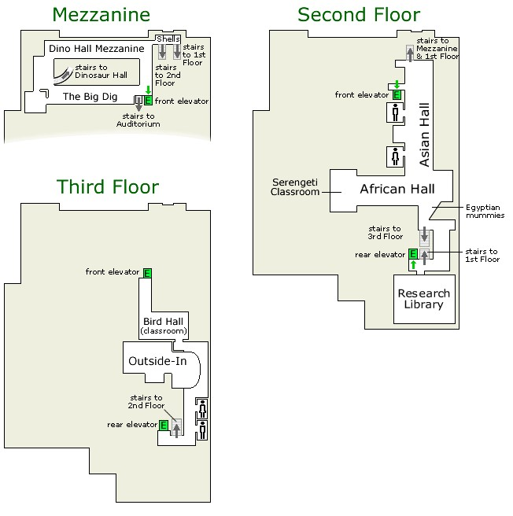
Requirements achieved | YES |  | NO
Comments in support of decision
_______________________________________________________________________
_______________________________________________________________________
_______________________________________________________________________
_______________________________________________________________________
_______________________________________________________________________
_______________________________________________________________________
Question 8: Read the attached article and complete the required documentation.

Use only the information required for the purpose of the documentation.
The law enforcement raid came on a crisp, cold night in late January, 1975, without a high profile. No involved planning. No SWAT team. No large show of force. No TV cameras. There was plenty of man power, though: a task force consisting of 10 agents from Group 22 of the U.S. Drug Enforcement Agency and 10 New York Police Department detectives attached to the Organized Crime Control Bureau (OCCB).The task force felt confident that it would face little resistance and certainly no bodyguards wanting to disrupt the raid and cause trouble. After all, it was the personal residence of the drug dealer and his family lived with him.

Group 22 had been investigating the Gambino crime family of East Harlem for some time, and now the long hours and hard work were about to pay off. In 1975 the Gambino family was one of the five families that ruled the powerful Italian American mob, La Cosa Nostra, and controlled organized crime in New York City The Gambino godfather, the "Boss of all Bosses," was the 5'7" hawk nosed, unassuming legendary mobster and close friend of popular crooner, Frank Sinatra, named Carlos Gambino.

Four years before, after Carlos's wife died of cancer, Uncle Sam tried to deport him to Sicily in Italy, but the godfather's lawyers convinced the court that their client had heart trouble and would not survive the trip. The deportation was stopped, but the OCCB put Gambino under constant surveillance, some would say harassment; they even parked a car round the clock in front of his home.

Under Gambino's leadership, his family became involved in large scale drug trafficking. The police, however, arrested two Gambino soldiers on drug trafficking charges, and, facing the prospect of long prison sentences, they began to sing like the proverbial canary. The soldiers revealed that one of their biggest customers for heroin was a prominent and flamboyant black drug dealer named Frank Lucas, who liked to call himself "Superfly." The informants' information allowed the authorities to obtain a search warrant, which authorized the raid that was about to begin on Lucas's house at 933 Sheffield Road in Teaneck, a small comfortable suburb in New Jersey. With a population of about 42,500, Teaneck had the distinction of being the first town in America where a white majority had voluntarily voted for the integration of the community's schools. But tensions flared in Teaneck in the late 1960s, as African-Americans moved into town, and whites began fleeing for parts Caucasian.

The racial tension did not bother Frank "Superfly" Lucas, who enjoyed the quiet suburban life after long nights on the streets of Harlem peddling his heroin. Business was booming and he had more money than he could spend and hide. Moreover, he had beaten a big rap that could have sent him to prison well into the next century. On this January evening, however, Superfly's world was about to be turned upside down. The strike task force knew that Lucas had a gardener, but the lawn looked in bad shape. A silver Mercedes

Benz and baby blue Thunderbird were parked in front.

After descending on Lucas's house, several members of the 20-man strike force fanned out and surrounded the house. It was normal police procedure. "We used to say to each other when we went on a raid: "take your baseball glove with you,'" Joe Sullivan, then a young DEA agent with three years' experience, recalled with a laugh. "People inside the house would rush up to the attic and throw drugs, handguns and money out the window, if they heard the agents at the door announcing their authority. It was a common headache for us."

The strike task force banged on the front door. "This is the police! Open up! We have a search warrant." The strike task force could hear panic and rapid movement inside and then a female screeching: "Where's the money!" We got to get rid of it." One of the people inside began bounding up the stairs. Outside the house, strike task force members watched as bags were thrown out the window.

When the task force barged through the door, they saw a big black man dressed in sweatpants and a sweatshirt shuffling cautiously towards them. The team identified the man from a mug shot as Frank "Superfly" Lucas. He looked as if his life had just flashed by him. "Let's see the warrants, officers," Lucas drawled in a strong southern accent.

Joe Rollo, a NYPD supervisor, handed the warrant to Lucas. "We're going to search your house," Rollo said. "We want everybody to go and wait in the dining room."

Lucas, two kids and a woman, who looked like a nanny or housekeeper, obeyed the order A few minutes later, they were joined by Julie, Lucas's petite, 28-year Puerto Rican wife, who had tried to sneak downstairs undetected. The team allowed Julie to go to the kitchen to get some milk for the kids. One officer followed her just to be sure she did not grab a gun. Julie turned around and snapped: "Why the hell are you following me? Where the hell can I go?"

Lucas barked in a deep, booming voice: "Calm down, woman! You're making too much noise." Julia was pretty, to be sure, sexy, in fact, and some of the task force members watched as she returned in a huff to the living room with the milk.

The house inside was larger than it appeared from the front. Lucas had built some extensions, including a huge playroom with a pool table, a ping pong table and a bar. In the master bedroom was a large closet containing shelves about 18 to 20 feet long. Joe Sullivan peaked inside the closet and was dazzled by a rainbow of colors: at least 200 pairs of lilac, purple, lime green shoes….alligator shoes, snake skin shoes, platform shoes…. "I had never seen anything like that in my life," Sullivan recalled. "I was a poor kid from Queen's (New York), who was lucky to wear one pair of shoes to school. Lucas had more shoes than he needed in a lifetime. It really said something about the guy."
Finding evidence was surprisingly easy. There were no guns or dope, but scattered throughout the house were bags of what Sullivan called "chump change," paper bags stuffed with "street money" in mostly $1 to $20 bills, with the occasional $100 thrown in.

Obviously, the money had not been counted, and the strike task force knew that the evidence would strengthen the charge that the house's owner was involved in a criminal conspiracy to sell drugs. "Lucas had no means of employment and a jury would think: ‘What does this guy do?'" Sullivan explained. "'He does not work, but he's got all this money in the house.

'"Counting the money made the raid seem as if it had lasted a lifetime. And it did not help matters that agents who had surrounded the house brought in more of the green stuff in the bags that Julie had tossed through the second floor bathroom window.

Julie became agitated again when asked the obvious question: "I didn't throw any god damn money out of the window," she insisted.

In looking for evidence, the strike task force divided into teams of three. One member looked for drugs, money and guns. A second agent took notes when evidence was found and recorded the seizure in a notebook. A third agent acted as a witness. As the agents found money, they brought it into the center of the living room. There, several task force members made a big circle around the pile. Everybody was in plain view of all the others present, and they were able to observe each other.

If an outside observer had encountered the scene, he might have thought that the authorities did not trust its task force to do the honest thing. Actually, the authorities were just protecting themselves against the potential charge off corruption.

In April 1970, New York City Mayor John V. Lindsay had formed the five-member Knapp Commission to investigate corruption charges in the NYPD. In the public hearings that began in October, 1971, the public heard shocking testimony from dozens of witnesses, including Police Commission Howard R. Leary, corrupt policemen, victims of police shakedowns and whistle blowers like Sgt. David Durk and Frank Serpico, who later became famous as model for the character in the 1973 movie, Serpico, starring Al Pacino in the lead role.

One of the Knapp Commission witnesses was Waverly Logan, a member of the NYPD's Preventive Enforcement Patrol, an elite unit of 20 black and Puerto Rican patrolmen with the specific assignment of reducing crime. Logan testified he took $1,500 a month in bribes and that police officers in Harlem routinely paid off informants with heroin in return for such stolen goods as cigarettes and whiskey.

The NYPD subsequently dismissed the former policeman for taking a $100 bribe. On Nov. 19, 1971, New York City established the OCCB to centralize organized crime enforcement. The objective: Combat potential corruption problems and unify under the bureau all operations of enforcement prone to corruption, such as vice, narcotics and organized crime. Still, law enforcement
remained under intense scrutiny. "The Knapp Commission hearings forced law enforcement in (New York City) to be extra careful about how we investigated crime," Sullivan recalled.It took the strike task force several hours to count the money in Lucas' house. Meanwhile, the streetwise gangster knew it was best to stay quiet, and he looked on impassively. Julie fell silent, resigned to the fact that the evening would not have a happy ending.Finally, in the wee hours of the morning, the strike task force told Lucas the money they had counted totaled $584,683. The gangster nodded; he did not appear to have a problem with the count. "We have enough evidence to arrest you," Rollo told Lucas and then read him his Miranda rights. Julia was also arrested for obstruction of justice. Throwing the money out of the window had not been the brightest of moves.

With Lucas and Julie handcuffed and in tow, the strike task force began streaming out of the house. To their surprise, outside waiting for them were the number two and number three officials in the DEA's New York office: Frank Monastero, the deputy director, and Jim Hunt, the head of enforcement. It was not a high profile bust, so something important must be up to get those two suits out of bed late at night.

Both of them were no-nonsense type of guys. Reserved and always impeccably dressed, Monastero had served as an Internal Revenue Service inspector for several years before joining the DEA's predecessor, the Federal Bureau of Narcotics, where he worked in Internal Affairs. The burly Hunt was a World War II veteran who had survived German machine gun nests on the beaches of Normandy in France. Jesuit educated, Hunt was a good amateur boxer and a graduate of Fordham University. "I remember Hunt as an intellectual tough guy," Sullivan recalled. "He liked to mix It was now biting cold outside, and the strike task force members could see their breath. But the two DEA officials stopped them and gave explicit orders. "I want you to line up and turn around and search the man behind you," Monastero instructed.

"I'll start by searching the first man in line." Some of the men laughed and thought their bosses were joking. Sullivan, though, was not one of them. He felt insulted. Here the strike task force had spent hours taking extraordinary precautions in collecting and counting Lucas's dirty money and their bosses upstairs still did not trust them. The pat down revealed nothing; no one had as much as a nickel in his pockets. Yet, years later, Sullivan recognized the procedure as the best move his bosses could have made. It provided irrefutable proof that the raid was squeaky clean.

I hereby grant permission for an
Authorised officer of ………
to inspect the contents of my v
ehicle or any container I may
have in my possession whilst I am on a site occupied by ……….
Date
Name of visitor/
contractor
Company
Tel:
Who is
being
visited
Vehicle
Register
Per. no
Time
in
Time
out
ID NO.
Hand
Sign

NUMBER: 00049
VISITORS REGISTER

KEY CONTROL REGISTER | of  pages | Received By
KEY CONTROL REGISTER | of  pages | Date Re-  turned
KEY CONTROL REGISTER | of  pages | Issued To:
KEY CONTROL REGISTER | ACTIVITY: Page
KEY CONTROL REGISTER | ACTIVITY: Page | Issued  By
KEY CONTROL REGISTER | ACTIVITY: Page | Date Issued
KEY CONTROL REGISTER | ACTIVITY: Page | No. of Keys  Issued
KEY CONTROL REGISTER | ACTIVITY: Page | Location
KEY CONTROL REGISTER | ACTIVITY: Page | Key Code  Number
_______________________________________________________________________
_______________________________________________________________________
_______________________________________________________________________
_______________________________________________________________________
_______________________________________________________________________
_______________________________________________________________________
_______________________________________________________________________
_______________________________________________________________________
_______________________________________________________________________
_______________________________________________________________________
Requirements achieved | YES |  | NO
Comments in support of decision
_______________________________________________________________________
_______________________________________________________________________
_______________________________________________________________________
_______________________________________________________________________
_______________________________________________________________________
_______________________________________________________________________

Question 9: To control unauthorized and authorized people, vehicles and goods at an access control point, the following guidelines will make it difficult for unwanted persons to gain access to premises:
_______________________________________________________________________
_______________________________________________________________________
_______________________________________________________________________
_______________________________________________________________________
_______________________________________________________________________
_______________________________________________________________________
_______________________________________________________________________
_______________________________________________________________________
_______________________________________________________________________
_______________________________________________________________________
_______________________________________________________________________
_______________________________________________________________________
_______________________________________________________________________
_______________________________________________________________________
_______________________________________________________________________
_______________________________________________________________________
_______________________________________________________________________ _______________________________________________________________________
_______________________________________________________________________
_______________________________________________________________________
_______________________________________________________________________
_______________________________________________________________________
_______________________________________________________________________
_______________________________________________________________________
_______________________________________________________________________
_______________________________________________________________________
_______________________________________________________________________
Requirements achieved | YES |  | NO
Comments in support of decision
_______________________________________________________________________
_______________________________________________________________________
_______________________________________________________________________
_______________________________________________________________________
_______________________________________________________________________
_______________________________________________________________________
Question 10: Study picture below and answer the relevant questions
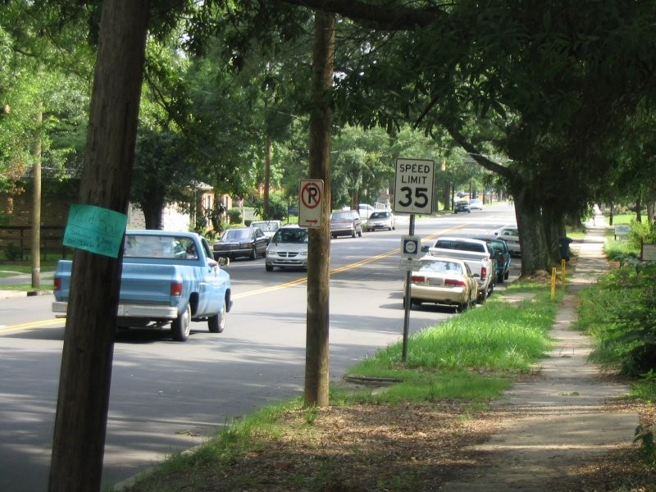
P 1
♦ Are there cars parked on the sides of the road?
♦ What color is the pickup truck driving in the road?
♦ Any minivans around?
♦ What does the blue sign say?
♦ What's the speed limit?
♦ Are there any pedestrians on the road?

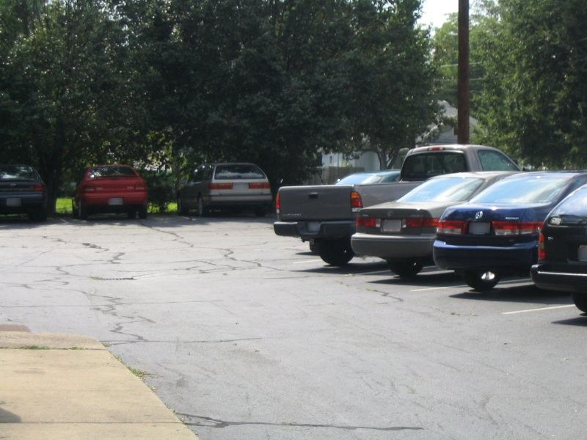
P 2
Investigators can use these questions to guide their inquiry, but may also think of their own questions.

♦ About how many cars can you see?
♦ Can you describe some of the cars in the lot?
Requirements achieved | YES |  | NO
Comments in support of decision
_______________________________________________________________________
_______________________________________________________________________
_______________________________________________________________________
_______________________________________________________________________
_______________________________________________________________________ Question 11: CASE STUDY: Read the case study below and record the situation on the attached documentation.

♦ OB

Obtain all the necessary information from the case study below. The documentation needs to be complete and contain all the necessary and correct information as outlined in the case study.

The sound of thunder and bright flashes in the sky may have been a wonderful spectacle last night, but what I didn’t realize was that it would cause one of the worst days of my life. I did not know about the power failure at three this morning because I was fast asleep. The first time I realized that my alarm did not go off, was at ¼ past five this morning – which meant that I was going to be late for work. I rushed while getting dressed and did not have time to iron my uniform because I had to run to get the last taxi. In my haste I forgot to put my pocket book in my pocket, and I could not find my shoes, so I wore takkies instead.

I actually made it to work, only 7 minutes late. My co-worker that had just finished night shift was not very impressed with me because he still had to do the handover. He was going to miss his taxi and would have to wait at least ½ hour for the next one. Because I felt guilty about coming late, I told him to go – I would read the OB to get the details of the night shift….

It looked like things were eventually settling down to a normal, boring working day. Cars stop, “morning sir”, “who are you visiting sir”, “that would be at block C – second building on the left”, “have a nice day sir”. The same thing, over and over. Sometimes I feel like a tape recorder. Cars come, cars go.

In the mean time I’m still a bit unsettled from all the rushing around this morning and tired from lack of sleep because I had to settle the kids down who were crying because they’re scared of the thunder and lightning.

Then the blue BMW stops at the gate about 09:20 . He hoots. So I wasn’t quite as observant as I am supposed to be – I am tired, you know. I paste my smile on my face and walk up to the driver’s window.

I get as far as saying: “Good morning, Sir.”

“Good? – good???; so what’s good about it?”

“Where is Mr. Brown? It’s ten past nine. These $%# taxis! They caused an accident that has made me late! Open this #%^ boom!
“Sir”, I say, “I have to search your vehicle before you enter.” And I think to myself that this guy is so rude - I haven’t done anything to him!

“Never mind about my boot, open this gate, you $|%&*@& “%&*(%$(*%$*%)@*”

By now I’m getting very upset. Who does he think he is to swear at me and call me names? I’ll show him….

“Sir, please get out of your vehicle and open the boot. I will not let you pass until I have searched your vehicle!” I tell him.

“Yes, you *%(%^(%#*% - I’ll get out” - he swears at me again. Now he’s done it. There’s no way that someone insults my mother like that and gets away with it. I will search every inch of his car, and today is the day that he will not pass my boom.

He gets out of the car, and that’s the last thing I remember before I see my supervisor’s face and feel him shaking me. I am lying on the ground, and the boom is pointing up into the sky with blue BMW paint all over it. My jaw hurts like hell…

Occurrence book entry
Dag en datum:
Day of week and date: 15 May 2008
 |  | AARD VAN VOORVAL/NATURE OF OCCURRENCE
VOLG Nr. SERIAL No. | TYD TIME
123 | 09:10 | Patrol back: During the routine patrol it was discovered that a housebreaking and theft occurred at the computer lab. The housebreaking and theft was reported to Mr.  Maseko the security manager on duty.
 |  | Mr. Maseko determined that a Mecer laptop was stolen (asset number 4342222) The incident was reported to the SAPS.
 |  | The SAPS Reference number is SAPS S/Side 123/08/2005. The investigation officer is inspector Botha(012) 321 4333.,
 |  | Signed: J Ramoba
Question 12: Study the case study below and answer the relevant answers.

During the morning shift a elderly man with a 4 year old boy holding his hand approach you to obtain access to the building.

It looked very suspiciously due to a big briefcase that the old man is holding. When you asked if you can help the boy replied “ My grandpa can not talk can I help you” You o n return asked to search the elderly man, boy and briefcase.

The boy then replied again. “yes you can search my grandpa but not me.

♦ Discuss the procedure that you should follow in this case.
♦ Also explain if the consent given by the boy are legal or not. Motivate your answer by discussing the requirements of consent.
♦ You found a firearm during your search!! What should you do?
♦
_______________________________________________________________________
_______________________________________________________________________
_______________________________________________________________________
_______________________________________________________________________
_______________________________________________________________________
_______________________________________________________________________
_______________________________________________________________________
_______________________________________________________________________
_______________________________________________________________________
_______________________________________________________________________
_______________________________________________________________________ _______________________________________________________________________
_______________________________________________________________________
_______________________________________________________________________
_______________________________________________________________________
_______________________________________________________________________
_______________________________________________________________________
_______________________________________________________________________
_______________________________________________________________________
_______________________________________________________________________
_______________________________________________________________________
_______________________________________________________________________
_______________________________________________________________________
_______________________________________________________________________
_______________________________________________________________________
_______________________________________________________________________
_______________________________________________________________________
_______________________________________________________________________
_______________________________________________________________________
_______________________________________________________________________
_______________________________________________________________________ _______________________________________________________________________
_______________________________________________________________________
_______________________________________________________________________
_______________________________________________________________________
_______________________________________________________________________
_______________________________________________________________________
_______________________________________________________________________
_______________________________________________________________________
_______________________________________________________________________
_______________________________________________________________________
_______________________________________________________________________
_______________________________________________________________________
_______________________________________________________________________
_______________________________________________________________________
_______________________________________________________________________
_______________________________________________________________________
_______________________________________________________________________
_______________________________________________________________________
_______________________________________________________________________
_______________________________________________________________________

Requirements achieved | YES |  | NO
Comments in support of decision
Customer valuable and firearm register |  |  |  |  |  |  | Pg Nr ...
Date | Name | Telephone | Firearm type / valuable item | Firearm  nr / valuable item nr | Owner signature |  | Access control security officer signature | Key Nr
 |  |  |  |  | In | Out | Access control security officer signature | Key Nr
_______________________________________________________________________
Where details does not appear in the case
study, request it from the assessor.
_______________________________________________________________________
_______________________________________________________________________
_______________________________________________________________________
_______________________________________________________________________
_______________________________________________________________________
Question 13: Provide detail explanation of the following:

♦ The meaning of premises as defined in the act.
♦ Dangerous object
♦ Reasonableness
_______________________________________________________________________
_______________________________________________________________________
_______________________________________________________________________
_______________________________________________________________________
_______________________________________________________________________
_______________________________________________________________________
_______________________________________________________________________
_______________________________________________________________________
_______________________________________________________________________
_______________________________________________________________________
_______________________________________________________________________
_______________________________________________________________________
_______________________________________________________________________
_______________________________________________________________________
_______________________________________________________________________ _______________________________________________________________________
_______________________________________________________________________
_______________________________________________________________________
_______________________________________________________________________
_______________________________________________________________________
_______________________________________________________________________
_______________________________________________________________________
_______________________________________________________________________
_______________________________________________________________________
_______________________________________________________________________
_______________________________________________________________________
Requirements achieved | YES |  | NO
Comments in support of decision
_______________________________________________________________________
_______________________________________________________________________
_______________________________________________________________________
_______________________________________________________________________
_______________________________________________________________________
_______________________________________________________________________
_______________________________________________________________________
Question 14: Study the images below and indicate where a search should take place.

Label the images starting with one
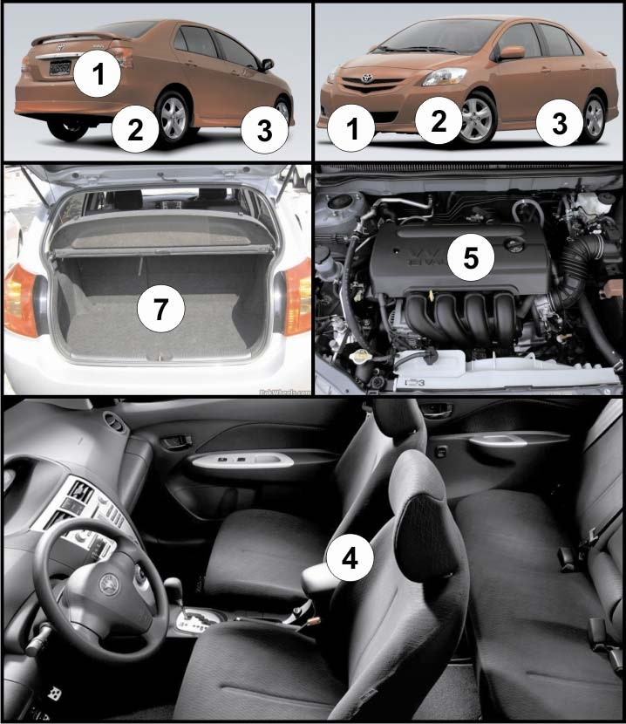
1.
2.
3.
4.
5.
6.
7.
Question 15: When searching a vehicle, person or a briefcase a security officer needs to know what he is looking for. List those critical factors that a security officer always needs to lookout for.
_______________________________________________________________________
_______________________________________________________________________
_______________________________________________________________________
_______________________________________________________________________
_______________________________________________________________________
_______________________________________________________________________
_______________________________________________________________________
_______________________________________________________________________
Requirements achieved | YES |  | NO
Comments in support of decision
_______________________________________________________________________
_______________________________________________________________________
_______________________________________________________________________
_______________________________________________________________________
_______________________________________________________________________
_______________________________________________________________________
_______________________________________________________________________
Question 16: What should be the two main characteristics of the questions asked of the person being searched?
_______________________________________________________________________
_______________________________________________________________________
_______________________________________________________________________
_______________________________________________________________________
_______________________________________________________________________
_______________________________________________________________________
_______________________________________________________________________
_______________________________________________________________________
Requirements achieved | YES |  | NO
Comments in support of decision
_______________________________________________________________________
_______________________________________________________________________
_______________________________________________________________________
_______________________________________________________________________
_______________________________________________________________________
_______________________________________________________________________
_______________________________________________________________________
Question 17: What are the general rules when you search someone?
_______________________________________________________________________
_______________________________________________________________________
_______________________________________________________________________
_______________________________________________________________________
_______________________________________________________________________
_______________________________________________________________________
_______________________________________________________________________
_______________________________________________________________________
Requirements achieved | YES |  | NO
Comments in support of decision
_______________________________________________________________________
_______________________________________________________________________
_______________________________________________________________________
_______________________________________________________________________
_______________________________________________________________________
_______________________________________________________________________
_______________________________________________________________________
Question 18: Study the image below and explain procedure to follow when searching a vehicle. Base your explanation of the procedures on the scenario below (image)
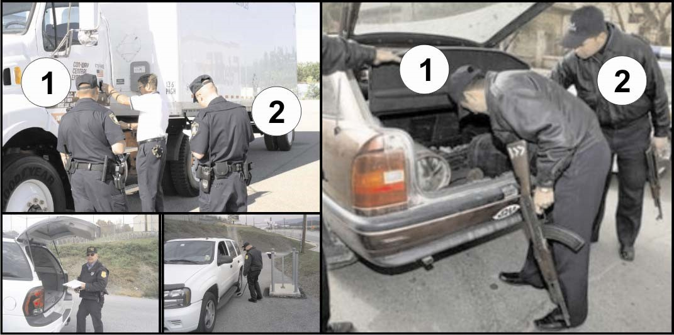
_______________________________________________________________________
_______________________________________________________________________
_______________________________________________________________________
_______________________________________________________________________
_______________________________________________________________________
_______________________________________________________________________
_______________________________________________________________________
_______________________________________________________________________
_______________________________________________________________________ _______________________________________________________________________
_______________________________________________________________________
_______________________________________________________________________
_______________________________________________________________________
_______________________________________________________________________
_______________________________________________________________________
_______________________________________________________________________
_______________________________________________________________________
_______________________________________________________________________
_______________________________________________________________________
Requirements achieved | YES |  | NO
Comments in support of decision
_______________________________________________________________________
_______________________________________________________________________
_______________________________________________________________________
_______________________________________________________________________
_______________________________________________________________________
_______________________________________________________________________
Question 19: You have received an operational instruction to escort valuables from the control room of your company to the human resource department. The valuables will arrive at the control room on Tuesday, 12 July 2006 at 09:00. You have to escort the valuables from the control room to Mr Strydom. Before you can undertake the escort, you have to do a complete threat assessment. Discuss the steps that you will follow when doing a threat assessment. (Guidelines for progression of the threat assessment)
_______________________________________________________________________
_______________________________________________________________________
_______________________________________________________________________
_______________________________________________________________________
_______________________________________________________________________
_______________________________________________________________________
_______________________________________________________________________
_______________________________________________________________________
Requirements achieved | YES |  | NO
Comments in support of decision
_______________________________________________________________________
_______________________________________________________________________
_______________________________________________________________________
_______________________________________________________________________
_______________________________________________________________________
_______________________________________________________________________
_______________________________________________________________________
Question 20: Escorting can take place on foot or by vehicle. Explain when you would do an escort on foot and when you would do an escort with a vehicle.
_______________________________________________________________________
_______________________________________________________________________
_______________________________________________________________________
_______________________________________________________________________
_______________________________________________________________________
_______________________________________________________________________
_______________________________________________________________________
_______________________________________________________________________
Requirements achieved | YES |  | NO
Comments in support of decision
_______________________________________________________________________
_______________________________________________________________________
_______________________________________________________________________
_______________________________________________________________________
_______________________________________________________________________
_______________________________________________________________________
_______________________________________________________________________

